# System Design Document

## UML Diagrams

### UML Use Case Diagram

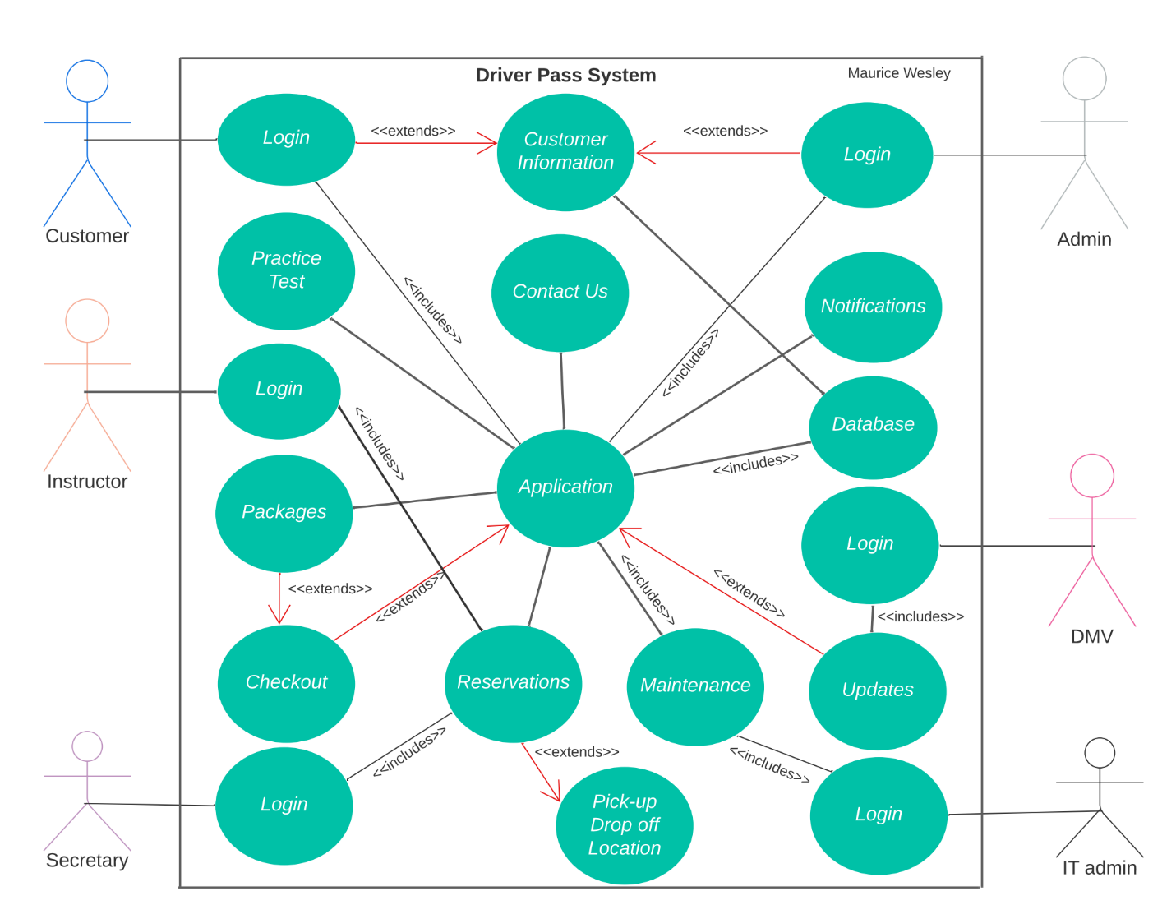

### UML Activity Diagrams 1

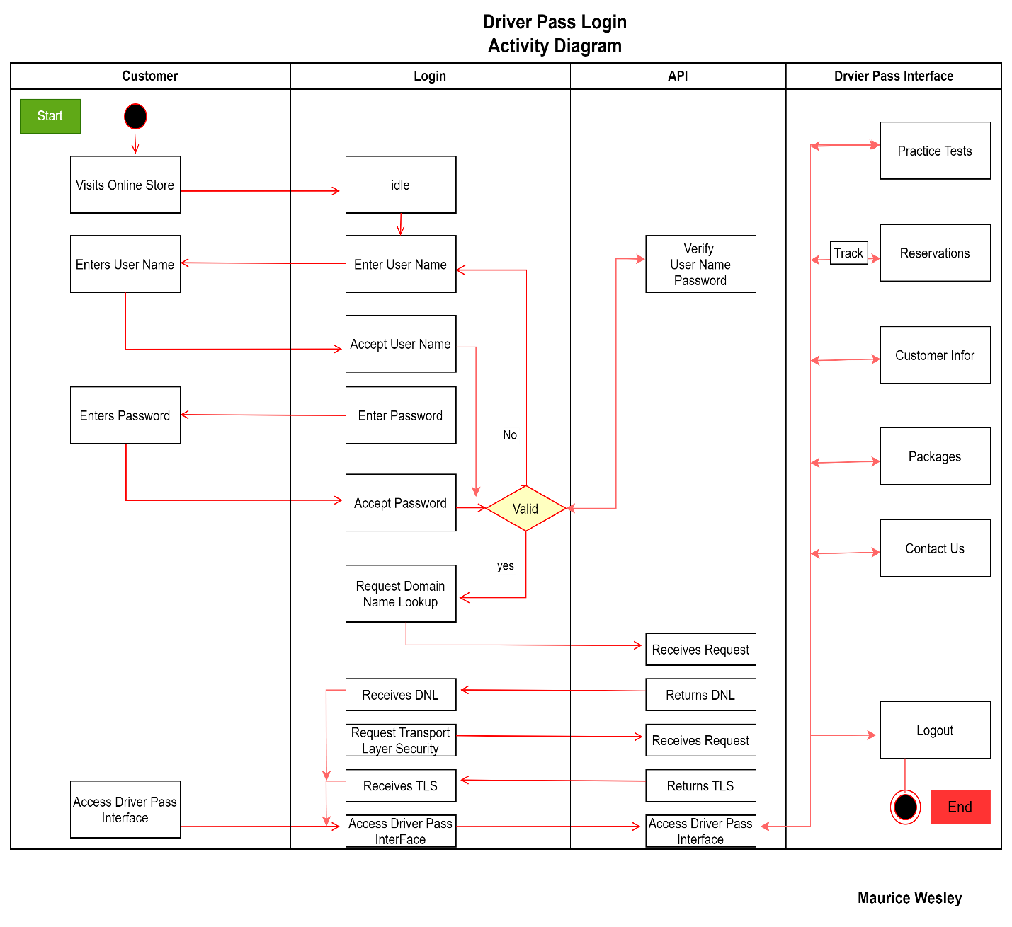

### UML Activity Diagrams 2

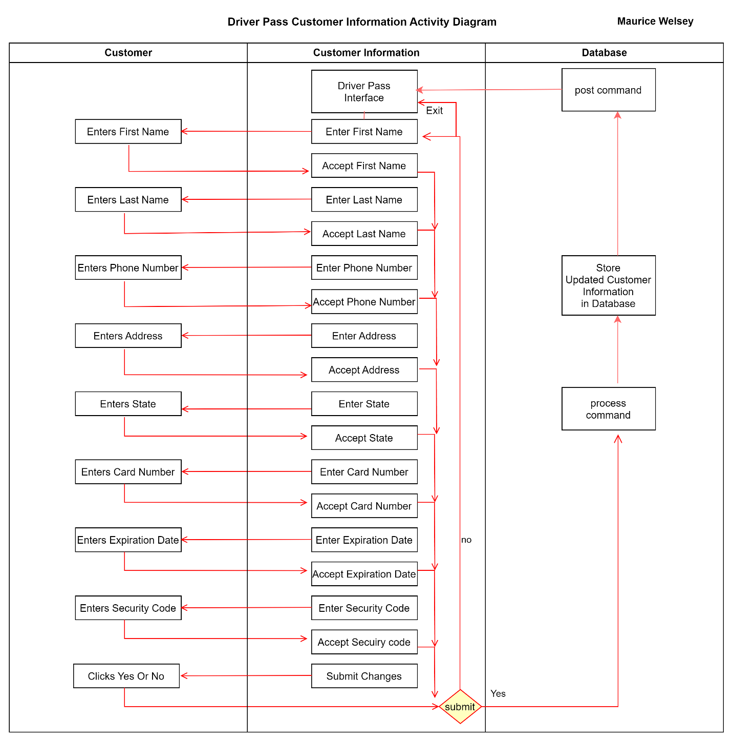

### UML Sequence Diagram

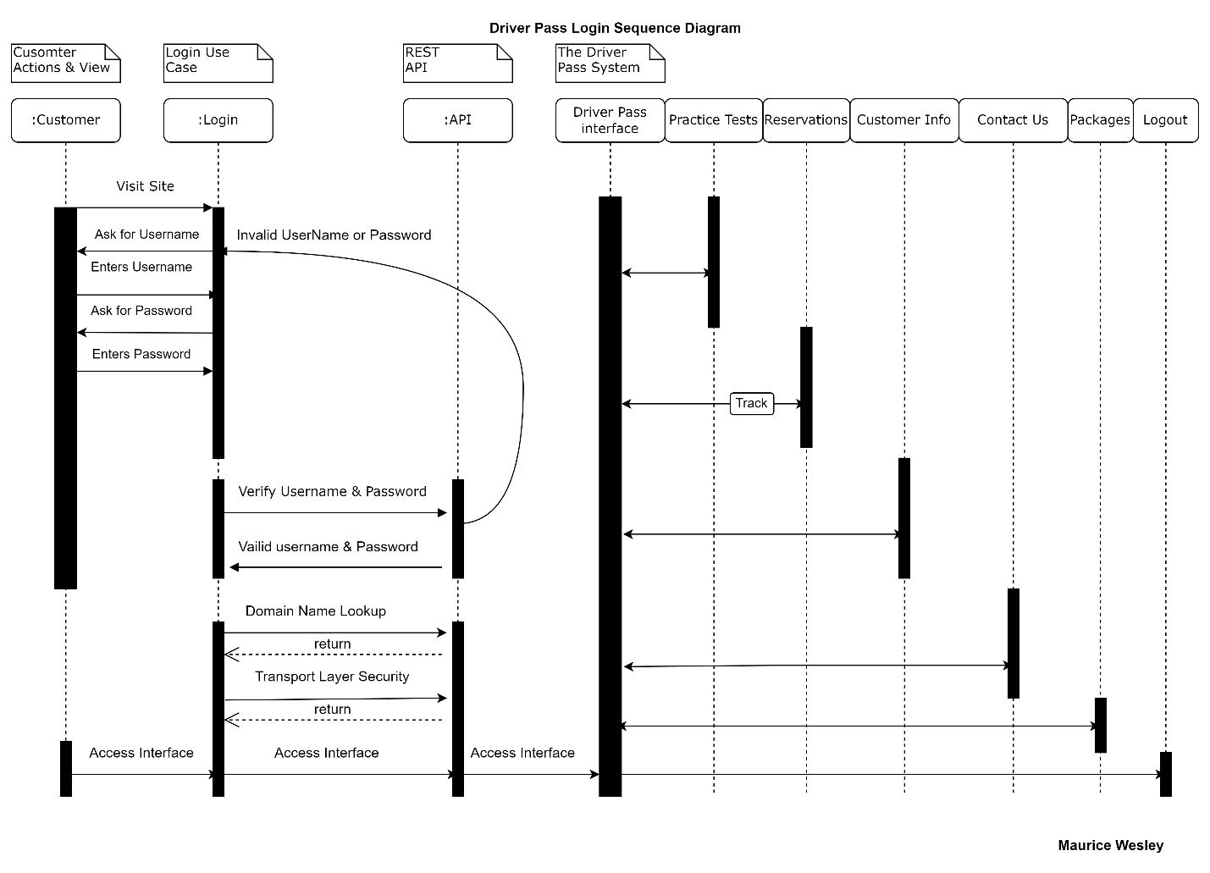

### UML Class Diagram

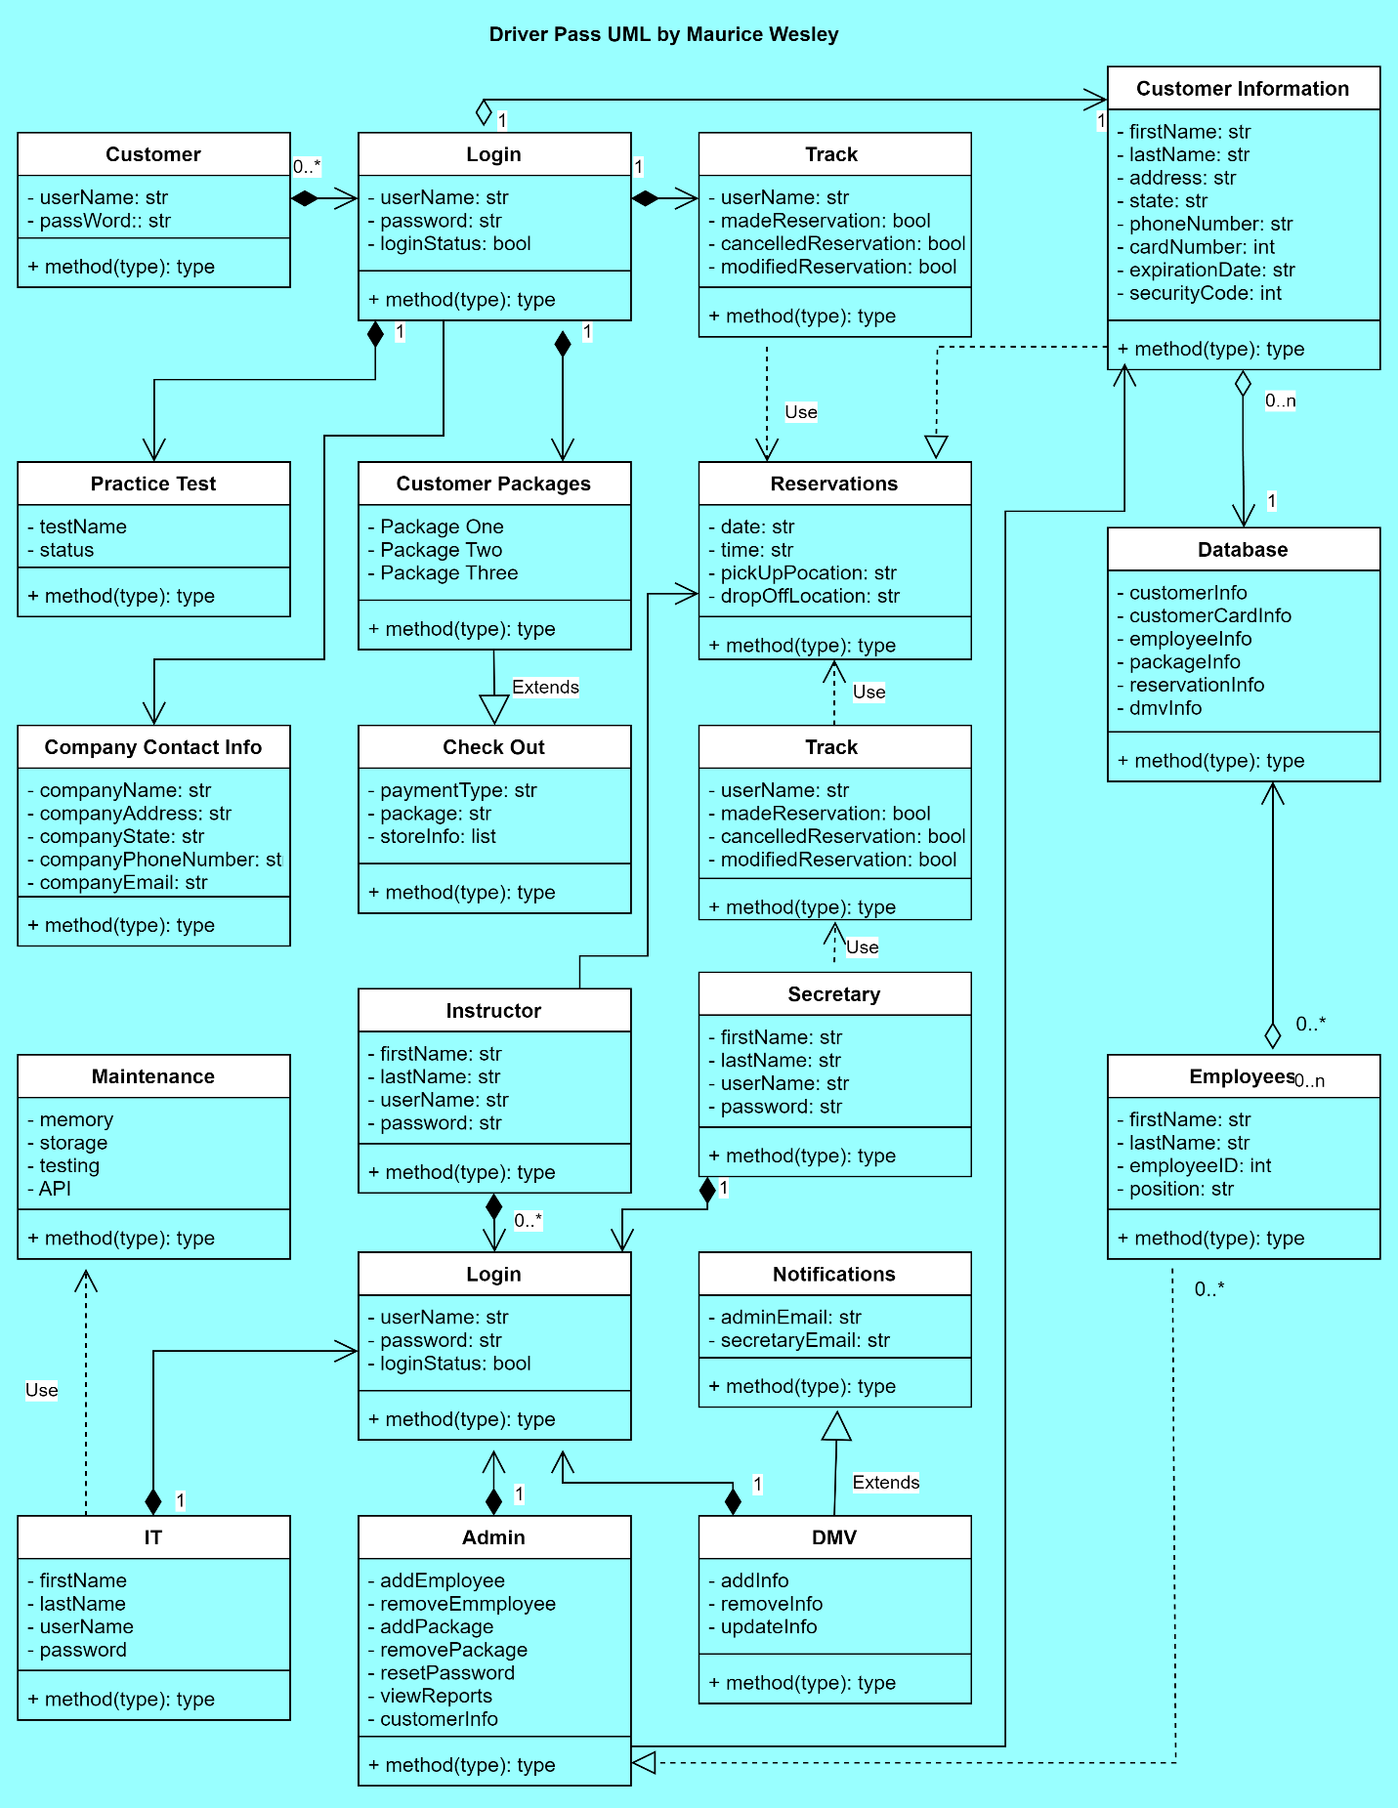

## Technical Requirements

**Hardware**: The system requires the admin, IT, secretary, and customers to have a computer, mouse, monitor, and/or mobile device. Also, these users must have an internet connection and a supported browser. The client does not need to purchase servers nor does the client want to worry about back-up and security. The web-based system shall be hosted and managed by the cloud service provider.

**Software**: The access to company data shall be located in a distributed environment with cross-platform functionality for different operating systems (Mac, Windows) including mobile devices (Android, IOS). The interaction between the user and the system should not exceed 5 seconds. To achieve this goal, our developers will utilize load balancing to reduce latency (Google, n.d.) and implement multi-threading to increase the responsiveness to the user. Oracle DB (mentioned in infrastructure)

The team will use a kernel to manage network communication, file management, and hardware integrations. The kernel will track memory, what processes are running, and process requests for service from processes (Red Hat, 2019). The kernel is open source and anyone can download and redistribute it. Oracle DB provides software for share memory that allows processes to share data and information.

**Tools**: Programming will be done using the cross-platform language java. Connecting java to a database will require java database connection (JDBC) software. Queries of the database will require script written in structured query language (SQL). Java provides tools to connect java, SQL, and the database which will provide additional tools for storage management. This will give the system the ability to store/retrieve customer information, practice tests, reservations, employee information, and updates provided by the DMV.

The client wants to assign privileges to specific types of users. The client wants to have complete access to the system, the IT to have the privilege to modify the system, and customers to login to a secure account to make payments. An application programming interface will be the primary tool used to facilitate the implementation of Role-Based privileges. The API will Implement case-sensitive Role-Based Authentication with privileges sub-divided into admin, IT admin, secretary, user, and DMV.

The admin shall enable/disable packages, reset passwords, make changes to customer information by logging into the system with the valid credentials. Afterwards, he can utilize predefined operations to add/modify/remove accounts without changing the code. Additionally, the system will have a Rest Controller that will restrict methods to only authenticated users in the Roles Allowed annotation with Admin or IT Admin passed as a parameter.

**Infrastructure**: The client mentioned that an IT employee will need to maintain or modify the system. The system will have a back-end for one of our team members and/or the IT employee to scale, modify, and maintain the system. Oracle DB will be a part of the infrastructure. The system will leverage Oracle DB’s partitioning schemes to in increase performance.

The system infrastructure will utilize system utility programs. The programs will provide file management and system administration. Additionally, the technician will manage network settings and disk partitions. Linux has a central location where developers can find and download applications like Ubuntu to manage applications in a distributed network.

Storage will be provided by the cloud host provider. The storage is scalable and can increase/shrink with demand. The client/system will leverage the cloud service provider’s hardware updates, back-up, and restore services Oracles DB provides Linux based automatic storage management service. The network servers will be provided by the cloud host provider. Possible consideration should be given to using AWS EC2 instances for network services. One instance should be sufficient until the system generates more demand.

The client wants to access the system and generate reports from anywhere. The system will utilize an AWS/Azure service called Infrastructure as a Service for cloud computing. Compute, storage, and network resources will be on-demand and pay-as-you go. IAAS provides all the infrastructure for web apps.

**Sources**

Silberschatz, Galvin, Gagne. (2022). *Operating system concepts*. [White Pages]. [Title Page | Operating System Concepts, 8th Edition (oreilly.com)](https://learning.oreilly.com/library/view/operating-system-concepts/9780470128725/silb_9780470128725_oeb_tp_r1.html)

Google. (n.d.). *Optimize application latency with load balancing*. Google Cloud. [Optimize application latency with load balancing  |  Load Balancing  |  Google Cloud](https://cloud.google.com/load-balancing/docs/tutorials/optimize-app-latency)

Red Hat. (2019). API security. [Blog Post]. [What is API security? (redhat.com)](https://www.redhat.com/en/topics/security/api-security)

Oracle. (2019). Automatic Storage Management. [White Paper]. [Oracle_19c_ASM_OverviewV1](https://www.oracle.com/docs/tech/database/asm-new-features.pdf)